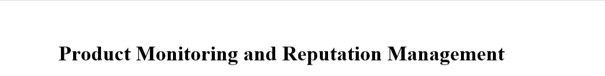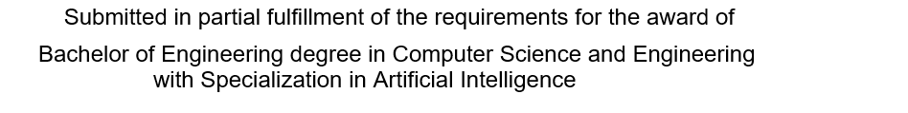

By

**Sethuramalingam G (Reg. No. - 40731090)**

**Nihal Kumar G (Reg. No. – 40731072)**



## DEPARTMENT OF COMPUTER SCIENCE AND ENGINEERING

**SCHOOL OF COMPUTING**

**SATHYABAMA**

**INSTITUTE OF SCIENCE AND TECHNOLOGY**

**(DEEMED TO BE UNIVERSITY)**

**Accredited with Grade “A++” by NAAC**

**JEPPIAAR NAGAR, RAJIV GANDHISALAI,**

**CHENNAI – 600119**

# APRIL- 2024

 **SATHYABAMA**

**INSTITUTE OF SCIENCE AND TECHNOLOGY**

### (DEEMED TO BE UNIVERSITY)

**Accredited with Grade “A++” by NAAC**

**(Established under Section 3 of UGC Act, 1956)**

**JEPPIAAR NAGAR, RAJIV GANDHI SALAI, CHENNAI– 600119**

[**www.sathyabama.ac.in**](http://www.sathyabama.ac.in)

# **DEPARTMENT OF COMPUTER SCIENCE AND ENGINEERING**

**BONAFIDE CERTIFICATE**

This is to certify that this Project Report is the bonafide work of **Nihal Kumar G (40731072)** who carried out the project entitled “**Product Monitoring and Reputation Management**” under my supervision from November 2023 to April 2024.

**Internal Guide**

**Ms. B. Balasai Gayathri M.E.,**

**Head of the Department**

**Dr. L. Lakshamanan M.E., Ph.D.,**

## Submitted for Viva voce Examination held on

**Internal Examiner External Examiner**

**DECLARATION**

I, **Nihal Kumar G (Reg. No. - 40731072),** hereby declare that the Project Report entitled **“Product Monitoring and Reputation Management”** done by me under the guidance of **Ms. B. Balasaigayathri M.E.,** is submitted in partial fulfilment of the requirements for the award of Bachelor of Engineering degree in **Computer Science and Engineering**.

## 

## DATE:

**PLACE: SIGNATURE OF THE CANDIDATE**

**ACKNOWLEDGEMENT**

I am pleased to acknowledge my sincere thanks to **Board of Management** of **SATHYABAMA** for their kind encouragement in doing this project and for completing it successfully. I am grateful to them.

I convey my thanks to **Dr T. Sasikala M.E., Ph. D**, Dean, School of Computing, **Dr S Vigneshwari M.E., Ph.D.,** Head of the Department of Computer Science and Engineering for providing me necessary support and details at the right time during the progressive reviews.

I would like to express my sincere and deep sense of gratitude to my Project Guide **Ms. B. Balasai Gayathri M.E,** for her valuable guidance, suggestions and constant encouragement paved way for the successful completion of my project work.

I wish to express my thanks to all Teaching and Non-teaching staff members of the **Department of Computer Science and Engineering** who were helpful in many ways for the completion of the project.

**ABSTRACT**

Online reviews are considered as one of the most essential sources of client opinion. In current scenario, consumers can learn about the products and services using online review resources to make decisions. The customer reviews for numerous products plays a very vital role not only for purchasers, But also for the firms. Consumer reviews are used by companies as feedback in their product development strategies and in the management of consumer relations. Due to their disorganized nature, consumer reviews with valuable information still face difficulties in navigating information. Driven by a need for profit, some organizations may generate spam reviews regarding different products or their own product which may mislead customers to buying unworthy product. Because of its promising commercial benefits, sentiment analysis has become one of the most interesting subjects in text analysis. The findings of this study shed light on the challenges and opportunities associated with product monitoring and reputation management in various industries. Moreover, the report presents a series of best practices and recommendations for businesses seeking to enhance their product monitoring capabilities and reputation management strategies. Through a deep exploration of real-world examples and current industry trends, this report not only emphasizes the importance of proactive product monitoring but also highlights the significance of a well-crafted reputation management strategy. It is evident that the effective management of product quality and reputation not only safeguards a company's brand but also fosters trust among stakeholders, enhances customer loyalty, and ultimately contributes to sustained business success. This project report serves as a valuable resource for professionals, executives, and researchers in the fields of marketing, public relations, and business management, providing insights and actionable recommendations to navigate the complex landscape of product monitoring and reputation management in the digital age.

|  |  |  |  |  |
| --- | --- | --- | --- | --- |
| **TABLE OF CONTENTS** | | | | |
| **S. No.** | **Title** | | **Pg. No.** | |
|  | Abstract | | v | |
| 1. | Introduction | | 1 | |
|  | 1.1 | Background |  | |
|  | 1.2 | Objectives of the Project |  | |
|  | 1.3 | Scope of the Project |  | |
| 2. | Literature Survey | | 3 | |
| 3. | Methodology | | 5 | |
|  | 3.1 | Research Design |  | |
|  | 3.2.1 | Machine Learning |  | |
|  | 3.2.2 | Random Forest Algorithm |  | |
|  | 3.2.3 | Page Rank Algorithm |  | |
|  | 3.2.4 | Customer Churn Prediction |  | |
|  | 3.3 | Ethical Considerations |  | |
|  | 3.4 | Tools and Software Used |  | |
| 4. | Description of Proposed System | | 12 |
|  | 4.1 | Monitoring Tools and Technologies |  | |
|  | 4.1.1 | Social media listening tools |  | |
|  | 4.1.2 | Review Monitoring Platforms |  | |
|  | 4.1.3 | Web-scraping Techniques |  | |
|  | 4.1.4 | Sentiment Analysis Software |  | |
|  | 4.2 | Architecture Diagram |  | |
|  | 4.3 | Data Visualization |  | |
|  | 4.3.1 | Ethical Considerations |  | |
|  | 4.3.2 | Limitations |  | |
| 5. | Conclusion and Future Work | | 18 |
| 6. | References | | 20 |
|  | Appendix | | 21 |
|  | Research Paper | | 42 |
|  | Certificate | | 48 |